Why do we need Automated Feature Engineering and Auto ML?
Automated Feature Engineering (AFE) and Automated Machine Learning (AutoML) play a vital role in modern data science, as they address one of the biggest challenges in building machine learning models, that is reducing time and complexity. Before AFE and AutoML, creating features and selecting algorithms were manual, time-consuming tasks requiring expert knowledge, AFE automates the transformation of raw data into useful features, while AutoML handles model selection, training and optimization. The combination of both allows models to be developed and deployed much quicker without ever sacrificing accuracy. According to DataRobot (2024), automation significantly shortens the model development cycle and enhances predictive performance by uncovering patterns that manual analysis might miss.
Furthermore, the need for AFE and AutoML lies in their scalability and accessibility. When dealing with massive and complex datasets, manual feature design becomes impractical and a hassle. Automated systems such as H2O.ai can process large-scale data consistently, which in turn ensures the reproducibility and reduces the need for experts. This means machine learning allows both experts and non-experts to utilize automation tools effectively, transforming raw data into valuable insight. Therefore, AFE and AutoML are now indispensable for achieving faster, consistent and scalable data driven decision making.
Resource :
DataRobot. (2024). The Role of Automated Machine Learning in Accelerating AI Development.
H2O.ai. (2024). H2O Driverless AI Documentation.

Automated Feature Engineering Definition and Basic Concepts
Automated Feature Engineering is the process where raw data is automatically transformed into new features (without doing it manually). In traditional feature engineering, feature creation was time-consuming and was an expert-dependent process. Nowadays, the rise of Machine Learning tools has made the process faster, more efficient and requires zero human intervention.
At its core, automated feature engineering is made up of four key concepts :
- Feature extraction : This involves generating a large number of features from raw data through operations like aggregations, transformations and time-based features (ex. Day of the month or time differences between events)
- Feature transformation : Once features are extracted, they are converted into suitable formats that ML algorithms can read. This step encapsulates numerical scaling and categorical variables, ex. Label encoding and one-hot encoding.
- Feature Selection : After a set of features is created, the system evaluates and filters them, keeping only the most relevant and useful ones, while discarding those that are redundant.
Resource :
https://www.tredence.com/blog/automated-feature-engineering#h2what-is-automated-feature-engineering-definitions-amp-core-conceptsnbsph2
https://www.geeksforgeeks.org/data-science/manual-vs-automated-feature-engineering/

AutoML Definition and Basic Concept
To grasp the concept of AutoML, three key terms need clarification to avoid confusion. CASH is a formal optimization problem focused on selecting the optimal combination of algorithm and hyperparameters, ultimately yielding a predictive model. Meanwhile, AutoML not only solves the CASH problem but also goes beyond it. AutoML encompasses CASH along with all the elements a skilled analyst would bring to the table, such as automated feature engineering, feature selection, the ability to estimate the predictive performance of models, and the capacity to explain and interpret the final model.

Featuretools and AutoML Tools
There are several popular tools available for automated feature engineering and AutoML. For automated feature engineering, Featuretools is one of the most widely used libraries, known for its ability to automatically generate meaningful features from raw data using a process called deep feature synthesis. On the other hand, in the field of AutoML, tools such as H2O AutoML, Auto-Sklearn, and Google Cloud AutoML are among the most popular choices for automating the machine learning workflow, including model selection, hyperparameter tuning, and evaluation. However, for the scope of this document, the focus will be on explaining Featuretools for automated feature engineering and H2O AutoML for automated model training and optimization.

AutoML vs Featuretools
 | AutoML | Feature tools
Purpose | Automates the full ML pipeline from data preprocessing, feature engineering, model selection and hyperparameter tuning. | Mainly works on automated feature engineering, transforms raw data into feature matrix.
How it works | Utilizes optimization techniques and model ensembling to choose and tune models. | Utilizes Deep Feature Synthesis (DFS) to recursively apply aggregation and transformation primitives across entity relationships.
Input | Works on entire dataset to pick models and pipelines | Works on input tables and their relationships to generate new features
Output | Trained ML model | A feature matrix for specific entity, with automatically derived features
Strengths | Reduces the need for human model tuning | Generates relational-aware features that would be difficult to create manually
Limitation | Could possibly overlook domain-specific ideas | Could possibly generate features that are less interpretable

Traditional ML Workflow vs AutoML (H2O and Featuretools)
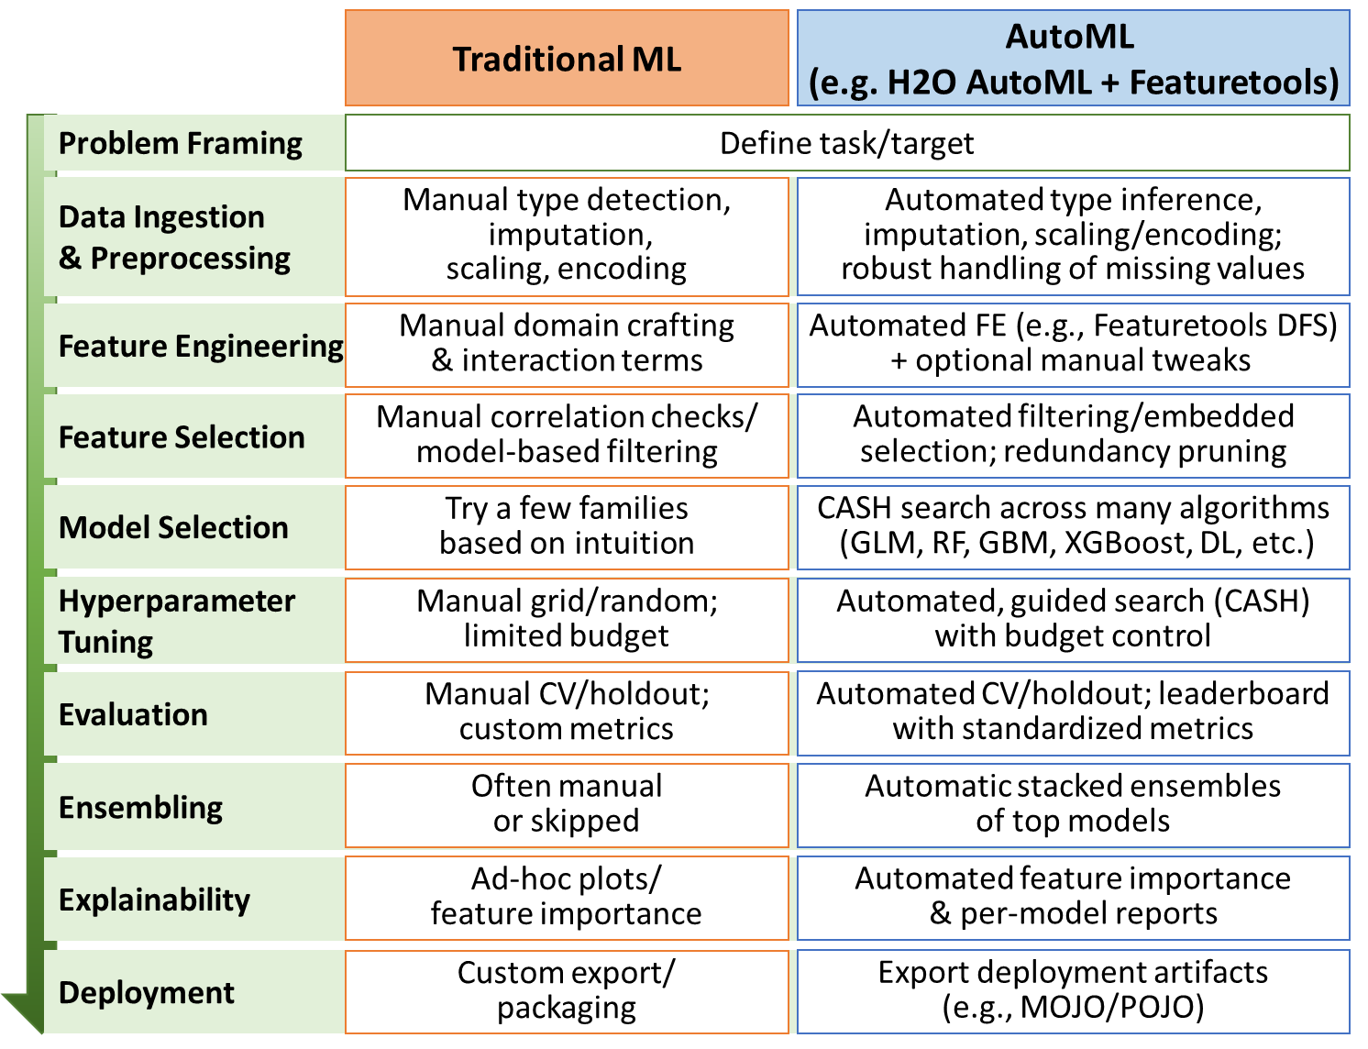

How does Featuretools Works

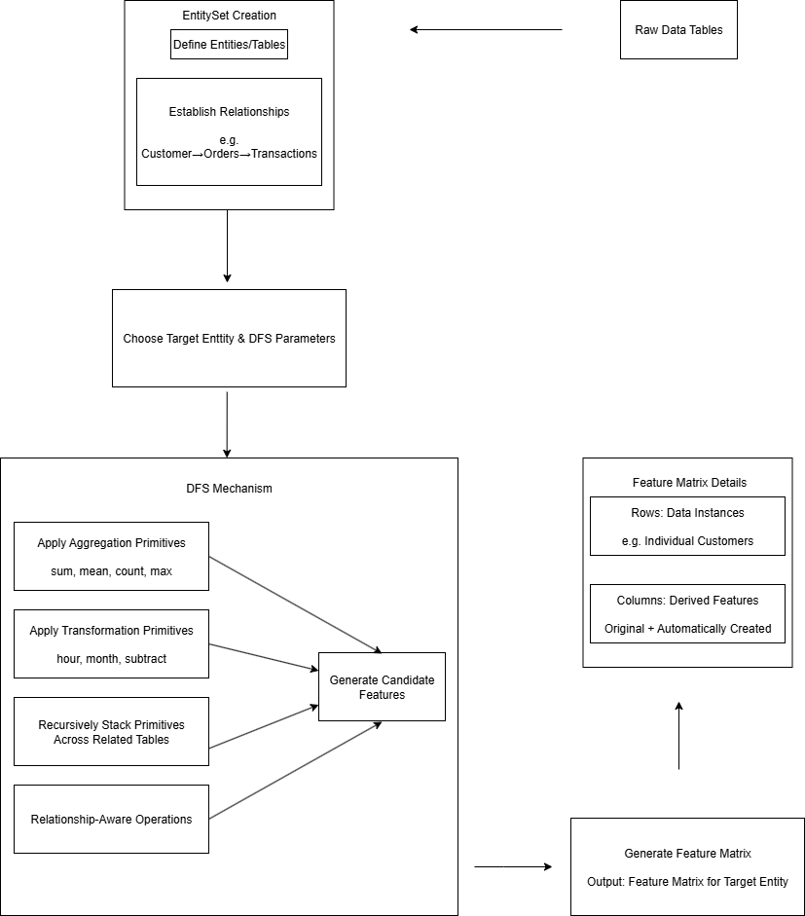
At its core, Featuretools is based on the idea of Deep Feature Synthesis (DFS). DFS automates the generation of new features by recursively applying aggregation and transformation primitives across relational and temporal data. In simple words, instead of manually creating new feature combinations, DFS automatically searches through and combines related data tables to make new features.
Featuretools use several key components in its mechanism, such as EntitySets, feature primitives, and relationship-aware operations. Firstly, the tool represents the data as an EntitySet ( a collection of entities or tables plus their relationships). Then it applies built-in primitives (for example, aggregations like sum, mean). These primitives may operate within a single table or across related tables. Through DFS, it stacks primitives to produce complex features automatically.
The process of using Featuretools follows these steps :
- Model the dataset with an Entity Set
Organize raw data as multiple tables (entities) and define their relationships (ex. Customers→ orders→ transactions). This collection of entities and relationships is called an EntitySet.
- Choose the target entity and DFS depth
Next, pick which entity that you want to generate features for and set how many levels of combinations you want the feature generation to explore.
- Run Deep Feature Synthesis (DFS)
Through DFS, Featuretools applies a set of primitives (aggregation, transformation) across and within entities based on the relationship that has been defined. This tool combines primitives to build candidate features.
- Generate the feature matrix
The output is a feature matrix for the target entity : a table where each row corresponds to a data instance (ex. customer) and each column is one of the derived features.

How does AutoML Works
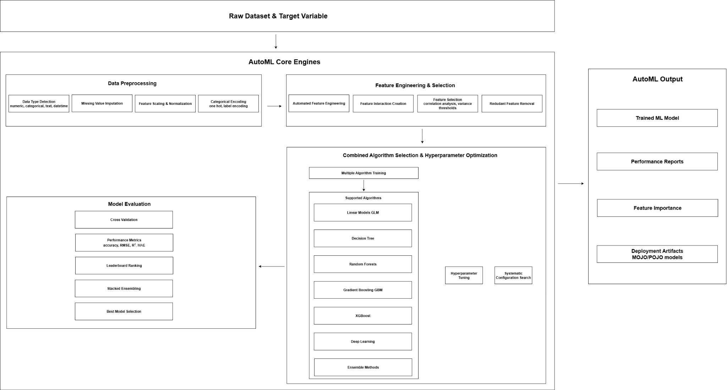
Automated Machine Learning (AutoML) is a framework designed to streamline the end-to-end process of building predictive models, reducing the need for manual intervention and deep expertise in machine learning. At a high level, AutoML takes a dataset and a defined target variable as input, and orchestrates a sequence of steps that encompass data preprocessing, feature engineering, model selection, hyperparameter tuning, evaluation, and deployment. By automating these stages, AutoML enables rapid experimentation and deployment of high-performing models while minimizing human error and bias. H2O AutoML, in particular, provides an efficient and scalable implementation of AutoML, capable of handling large datasets and offering options for distributed training on multiple cores or nodes.
The process begins with automatic data preprocessing, where AutoML identifies the type of each variable, such as numeric, categorical, text, or datetime, and applies appropriate transformations. This can include imputing missing values, normalizing or scaling numeric features, encoding categorical variables, and extracting structured information from text or temporal data. H2O AutoML also automatically converts categorical columns into one-hot or internal integer representations and efficiently handles missing data during model training. The system ensures that the input dataset is transformed into a machine-learning-ready format, capable of being consumed by multiple modeling algorithms. In parallel, some AutoML frameworks incorporate automated feature engineering, generating new features through mathematical transformations, feature interactions, or aggregated values that can improve model expressiveness and predictive power. While H2O AutoML does not perform advanced automated feature engineering by default, it can integrate with tools like Featuretools to enrich the dataset before training.
Following preprocessing, AutoML performs feature selection to identify the most informative attributes while removing redundant or irrelevant features. Techniques such as correlation analysis, variance thresholds, and model-based embedded selection are used to refine the feature set, improving model efficiency and generalization. Once features are finalized, AutoML enters the model search and optimization phase, known as Combined Algorithm Selection and Hyperparameter Optimization (CASH). In this stage, multiple candidate algorithms, ranging from linear models and decision trees to ensemble methods and neural networks, are trained and evaluated. H2O AutoML supports algorithms such as gradient boosting machines (GBM), random forests, generalized linear models (GLM), XGBoost, and deep learning models, and systematically tunes hyperparameters to identify optimal configurations.
Each candidate model is evaluated through cross-validation or holdout validation, producing performance metrics such as accuracy, RMSE, MAE, or R² for regression tasks. AutoML ranks the models on a leaderboard, highlighting their relative performance. H2O AutoML further enhances accuracy using automatic stacked ensembles, which combine predictions from multiple top-performing models to produce a final ensemble model that typically outperforms individual learners. Finally, AutoML outputs the selected model along with performance reports, feature importance rankings, and deployment-ready artifacts, such as MOJO or POJO models, enabling seamless integration into production workflows.
In summary, AutoML encapsulates the full machine learning lifecycle, automating repetitive and computationally intensive tasks while maintaining robust performance. By systematically preprocessing data, generating and selecting features, exploring a diverse set of algorithms, optimizing hyperparameters, and combining models through ensembling, H2O AutoML delivers high-quality predictive models with minimal manual intervention, making advanced machine learning accessible to a broader audience.

How does AutoML and Featuretools Work Together
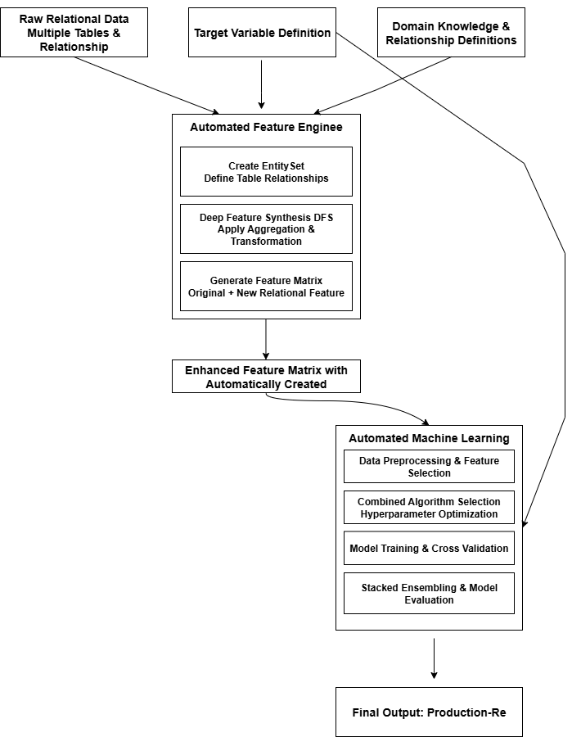
Featuretools and AutoML work together in a complementary way to automate the entire machine learning pipeline. Featuretools focuses on automated feature engineering by applying Deep Feature Synthesis (DFS) to transform raw data into a rich feature matrix that captures complex relationships among variables. This feature matrix, containing both original and newly created features, is then used as input for AutoML. AutoML automates the next stages of the process, including data preprocessing, feature selection, algorithm selection, hyperparameter optimization (CASH), and model evaluation. By combining the strengths of both tools, Featuretools ensures that the data representation is as informative as possible, while AutoML ensures that the model built from this data is the most accurate and efficient. Together, they form a powerful workflow that reduces manual effort, accelerates experimentation, and produces high-performing predictive models with minimal human intervention.

How it Differs from Traditional ML Workflow
In a traditional machine learning workflow, data scientists manually do these steps such as, data cleaning, feature engineering, model selection, hyperparameter tuning, and evaluation. This steps requires knowledge in this field and is time-consuming due to trial and error in designing features and selecting models.
In comparison, AutoML and FeatureTools workflow automates most of the process. FeatureTools applies automated feature engineering by generating new features from raw relational data through Deep Feature Synthesis.
The main difference is that traditional ML relies heavily on human experts to design and optimize pipeline, while AutoML and FeatureTools utilize algorithms to explore and generate the best solutions with no or minimal human intervention. This automation makes prototyping quicker, reduces human bias and allows non-experts to achieve good results.

Case Scenario Where This Workflow is Useful
In a house price prediction scenario, a real estate company seeks to forecast the market value of houses based on various features. The dataset includes attributes such as MedInc (median income), HouseAge, Latitude, Longitude, AveRooms (average number of rooms), AveBedrms (average number of bedrooms), Population, and AveOccup (average occupancy). The process begins with Featuretools, which takes the California housing dataset as input and applies Deep Feature Synthesis (DFS) to automatically generate additional features. This results in a comprehensive feature matrix that combines both the original and newly created features. The next stage involves AutoML, which uses the feature matrix from Featuretools as input. AutoML automates several steps of the machine learning pipeline, including data preprocessing, feature selection, CASH (Combined Algorithm Selection and Hyperparameter Optimization), and performance evaluation. The final output of this process is the best-performing predictive model capable of accurately estimating house prices across California.

- Mindmap Summary
